**VIRTUAL LABORATORY FOR COMMUNICATION SYSTEMS**

Rojin Raju1, Sri Sakticharan2, Umesh Hariharasudan M3, Ms. Thyla B4

1,2,3*Students, Department of Electronics and Communication Engineering,*

4*Professor, Department of Electronics and Communication Engineering*

*KCG College of Technology, Chennai.*

***Abstract*-** *The major goal of this paper is to provide a method to practice and understand various experiments related to communication systems laboratory remotely using virtual lab simulations.*

*In this paper we have presented working of virtual simulators to carry out various modulation techniques involve in communication systems. The virtual lab setup can improve the understanding of concepts by providing an easy to access, remotely available platform to carry out the experiments as many times as the user needs. The setup only requires a laptop/desktop with any modern browser and a proper internet connection.*

***Keywords -****simulator, web development, education-aid, remote-lab.*

**INTRODUCTION**

We are unable to conduct studies due to physical distances and a lack of resources, particularly when advanced apparatus is involved. To some extent, web-based and video-based courses address the issue of teaching. It has always been difficult to conduct joint experiments across two participating institutions while also sharing expensive resources. With today's internet and computer technology, the limits mentioned above can no longer prevent students and researchers from improving their skills and knowledge. In a country like ours, expensive instruments and equipment must be shared as much as possible with other researchers. Virtual labs strive to enable students at all levels, from undergraduate to graduate, with remote access to laboratories in a variety of science and engineering fields. It also plans to create a comprehensive learning management system that will allow students to access a variety of learning resources, such as supplementary web resources, video lectures, animated demonstrations, and self-evaluation. Students can use virtual labs to practise and understand science, engineering, and the experiments that go along with it. The Ministry of Human Resource Development of the Government of India launched the virtual lab as part of the national mission on education via information and communication technologies. Virtual laboratories are springing up in school districts and online learning curricula around the country, making remote experimentation easier and less expensive for students.

The virtual laboratory is a playground for experimenting, with an interactive platform for creating and conducting simulated experiments.

**LITERATURE SURVEY**

In [1] the v-lab focuses on biotechnical experiments and requires additional software and resources. In [2] the focus is on providing pre-recorded lectures and resources compared to letting the user experiment with different values. In [3] the study focuses on the advantage of virtual labs in improving self-paced learning. In [4] the study supports the involvement of virtual labs to improve the user engagement in blended education scenarios in universities.

**METHODOLOGY**

In this paper we present a system such that; The user enters the experiment page and will be able to view the Aim, Apparatus Required, Theory, Procedure, Pre-test, Experiment Simulation, Post-test and Result sections.

The user is expected to go through the sections in the provided order in order to get a proper understanding of the experiment.

The aim gives a proper definition of the experiment which needs to be carried out. The apparatus required gives the list of devices used to perform the experiment physically. The Pre-test gets the user aware and in touch with the field of experiment.

The simulations tab consists of components which can control the parameters involved in the experiment similar to its real life equivalent.

The graphs or waveforms involved in the experiment will be provided in a canvas which can be varied according to the change in parameters.

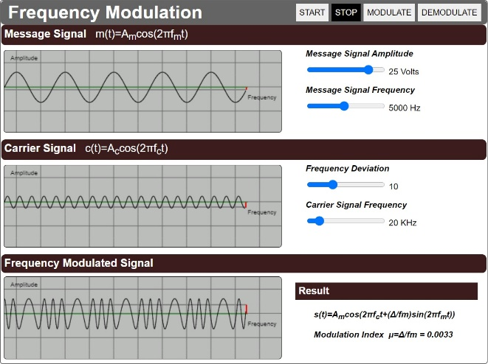

Fig.1 modulation screen of simulator (FM).

The waveforms will be displayed in an easy-to-understand manner with contrasting colours and fluid motion.

The parameters can be changed using sliders which indicate the values along with their units.

The formulas to be used will be displayed along with the results and observation towards the end of simulation window.

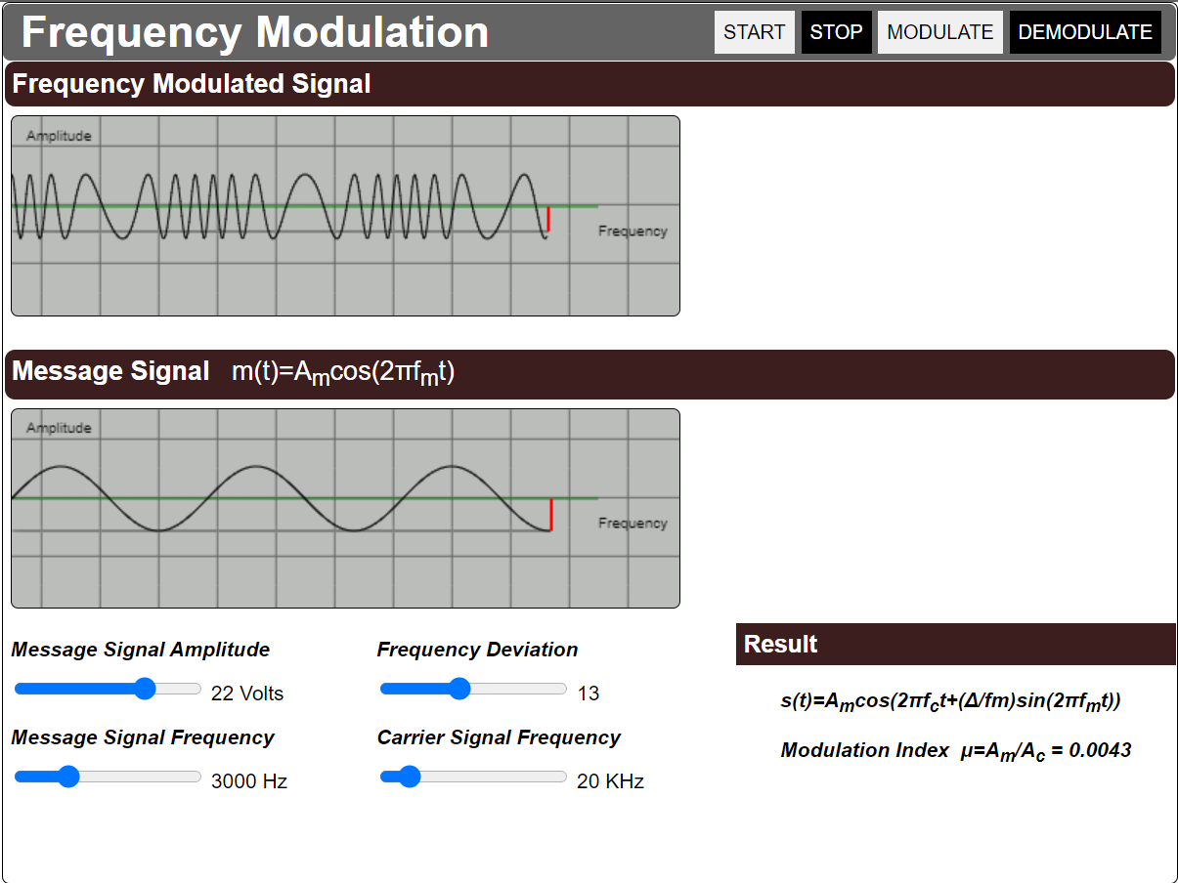

Fig.2 modulation screen of simulator (FM).

Each important step in the simulation will be prefaced with a quiz question which will help the user understand the steps and concept behind each step more effectively.

After the simulation is performed and the waveforms are studied by the user, they proceed to the post-test section which contains questions based on the experiment they performed.

This will ensure a clear understanding of the concept with an easier way to visualize these waveforms involved.

**SOFTWARE**

**HTML** **(Hypertext Markup Language)**:

It is the most fundamental component of a Web page. It establishes the structure and content of web pages. HTML is made up of a set of elements that are used to surround or wrap distinct parts of the material in order to make it look or perform a certain way. The enclosing tags, for example, can make a word or image hyperlink to another location, italicise words, change the font size, and so on.

**CSS (Cascading Style Sheets (CSS):**

It's a stylesheet language for describing the presentation of an HTML or XML document. CSS specifies how elements should appear on a screen, on paper, in speech, or in other forms of media. According to W3C guidelines, CSS is one of the basic languages of the open web and is standardised across Web browsers.

**Javascript:**

It's a first-class compiled programming language that's lightweight, interpreted, or just-in-time compiled. While it is best known as a scripting language for Web sites, it is widely used in a variety of non-browser situations. JavaScript is a single-threaded, prototype-based, dynamic language that supports object-oriented, imperative, and declarative programming techniques. The ECMAScript Language Specification is the standard for JavaScript.

**SYSTEM ARCHITECTURE**

The project is structured in such a way that the HTML file acts as the core skeletal structure which can access every other script, images and style-sheets required for the simulator.

Every image, CSS and javascript files are placed in their respective folders. This makes it easier to call these files from within the HTML

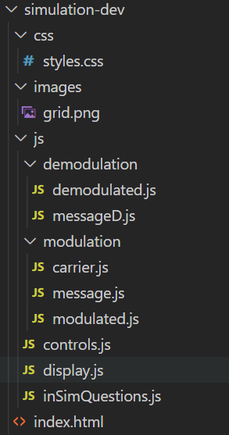

Fig.3 Structure of files.

The javascript codes are also divided into modules depending on the task they are assigned to carry out.

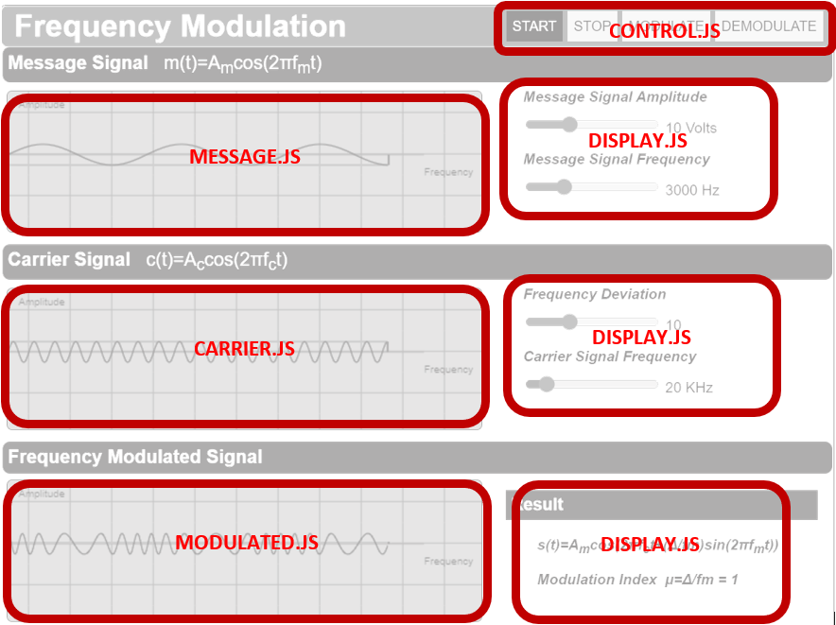

Fig.4 Functional blocks of modulation screen

The display.js takes care of the input values from the sliders and relays these values to the functions which calculate the values for parameters like modulation index.

The control.js takes care of the functioning of the buttons like start, stop, modulate and demodulate.

The modulation folder contains scripts responsible for the waveforms corresponding to the message, carrier and modulated signals.

Each waveform is drawn using canvas, which is an html tool used to generate graphical illustrations using javascript.

The message.js generates a message signal based on the input voltage and frequency retrieved from display.js. It consists of two functions, one to calculate the value of message signal according to their respective formulas (either a sine wave or a square wave), the other function plots the wave form on the canvas while providing an animation for its path of propagation.

The carrier.js generates the carrier signals based on the input of the voltage and frequency retrieved from display.js. It consists of two functions, one to calculate the value of a high frequency carrier signal with appropriate max voltage using appropriate formulas, the other function plots the waveform of this signal on the canvas while providing an animation of its propagation path.

The modulated.js file generates the modulated signal based on the simulated experiment. It computes the value of the modulated signal using the respective formulas. The modulated signal is plotted on the canvass based on the calculated signal with respect to time.

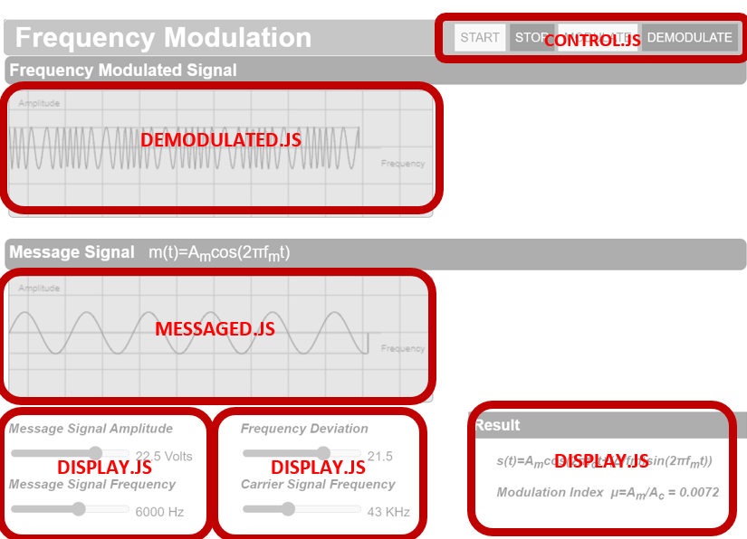

Fig.5 functional blocks of demodulation screen.

When the “demodulate” button is clicked, the demodulation screen will be displayed. This function is carried out by the control.js file. In the demodulation screen the values from the sliders for each parameter is controlled and displayed through the display.js file. It also takes care of showing the result which involves a dynamic value like modulation index when necessary.

The demodulated.js file performs the same function as the modulated.js in the demodulation screen. It takes in the parameters from the display.js file and computes the value of modulated signal and plots the waveform accordingly.

The messageD.js file performs the demodulation of the modulated signal and produces back the message signal.

Additionally, the inSimQuestions.js file prompts multiple choice questions when each control button is pressed. This is to ensure the understanding level of the concept by the user.

**OUTPUTS**

Amplitude Modulation simulator will yield the following result.

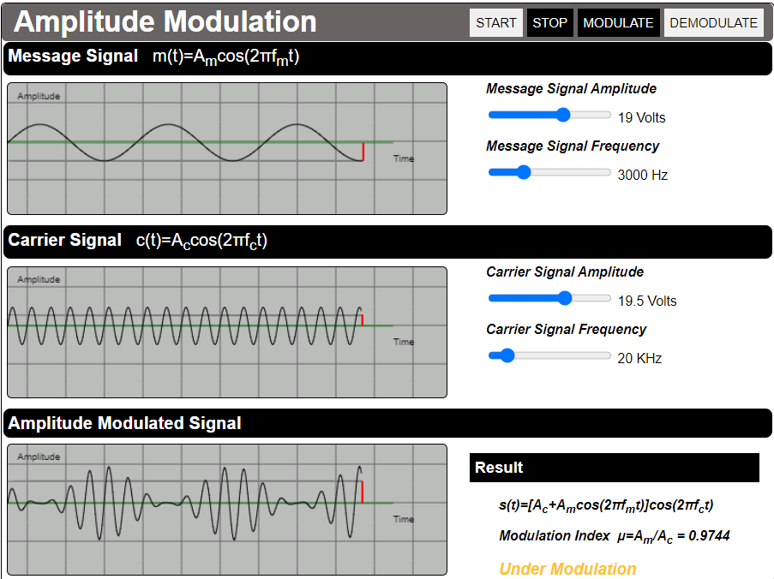

Fig. 6 Modulation screen of AM simulator

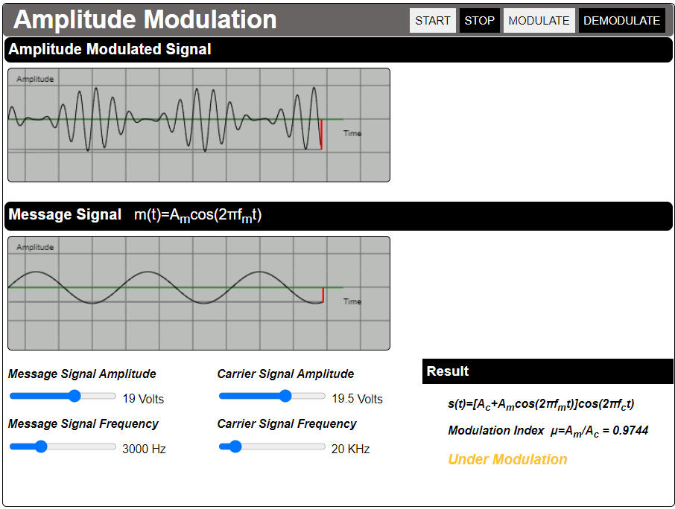

Fig. 7 Demodulation screen of AM simulator.

Frequency Modulation simulator will yield the following result.

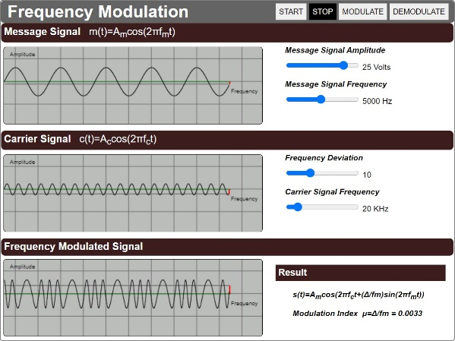

Fig. 8 Modulation screen of FM simulator



Fig. 9 Demodulation screen of FM simulator

Amplitude shift keying simulator will yield the following result.

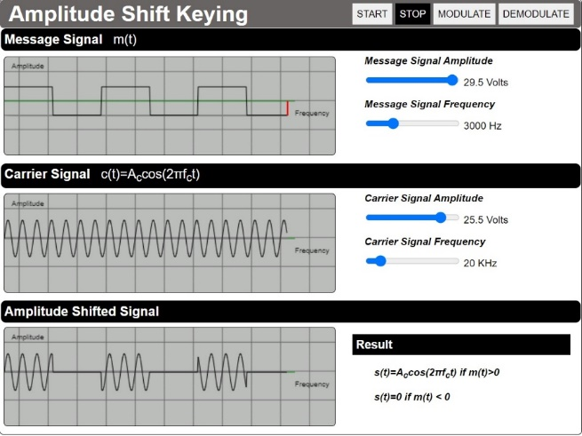

Fig. 10 Modulation screen of ASK simulator

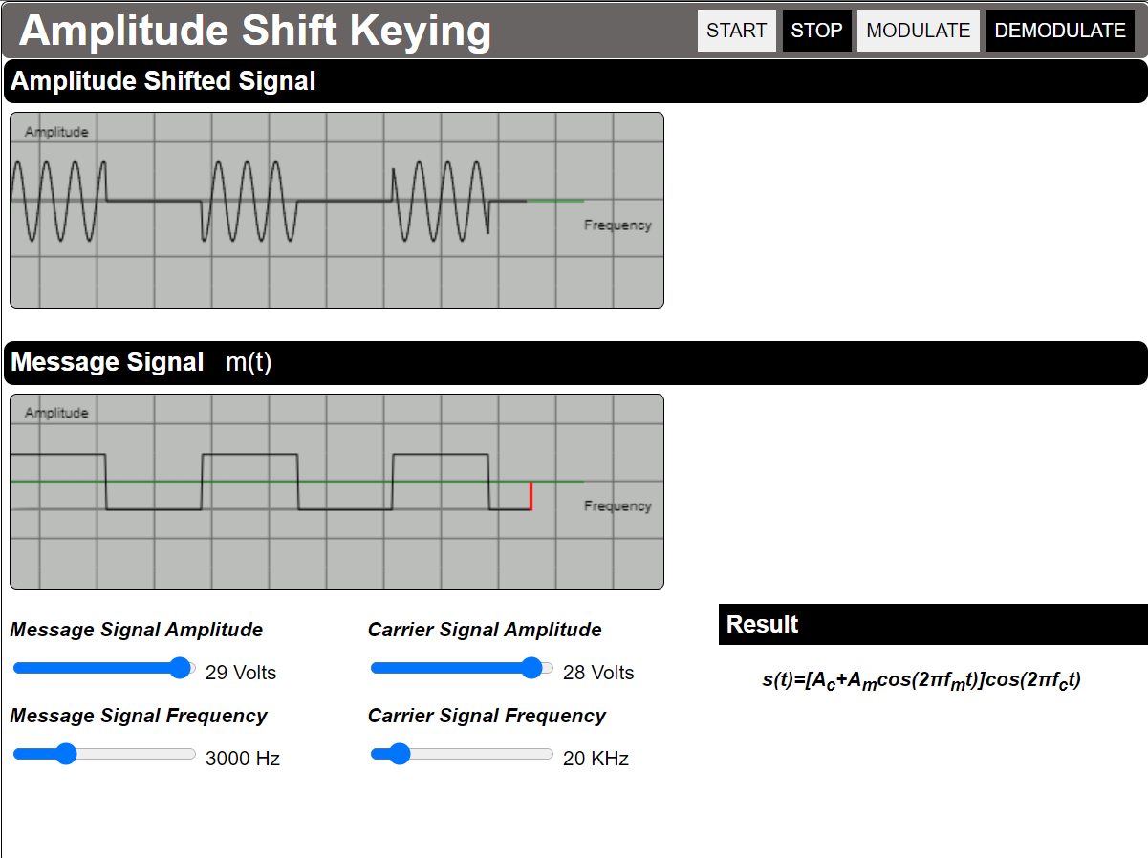

Fig. 11 Demodulation screen of ASK simulator

Frequency shift keying simulator will yield the following result.

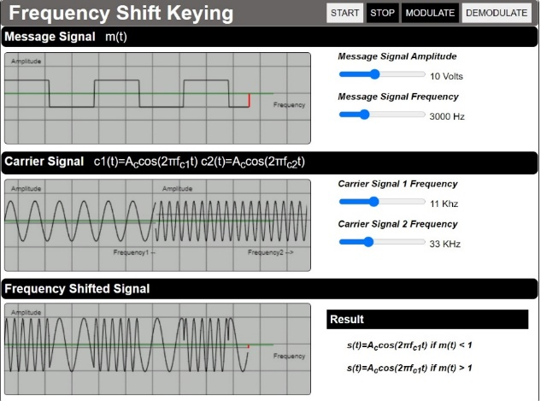

Fig. 12 Modulation screen of FSK simulator

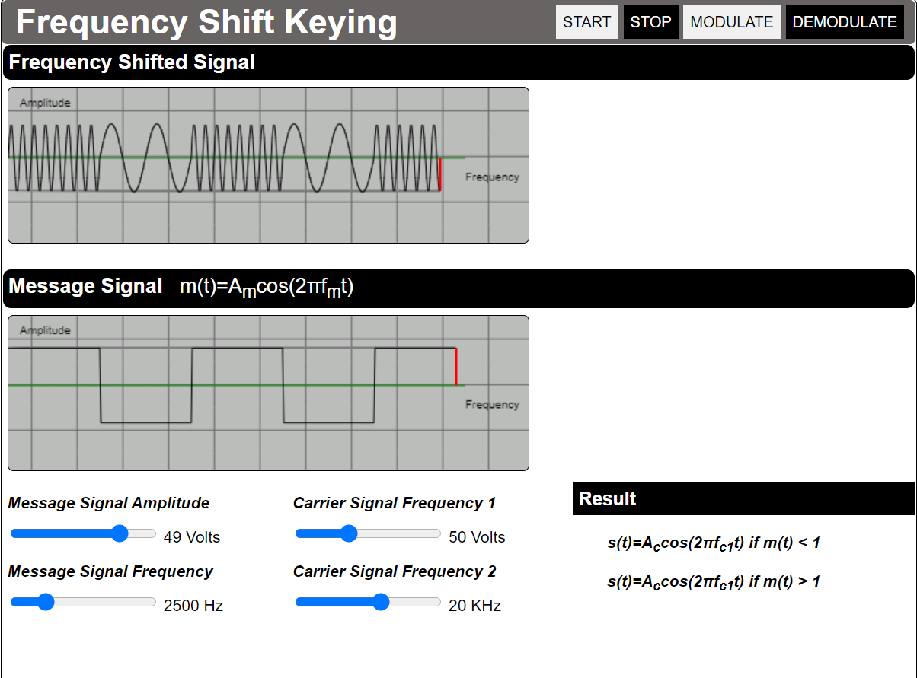

Fig. 13 Demodulation screen of FSK simulator

Pulse code modulation simulator will yield the following result.

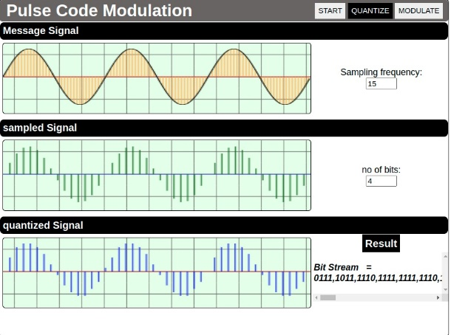

Fig. 14 Quantization screen of PCM simulator

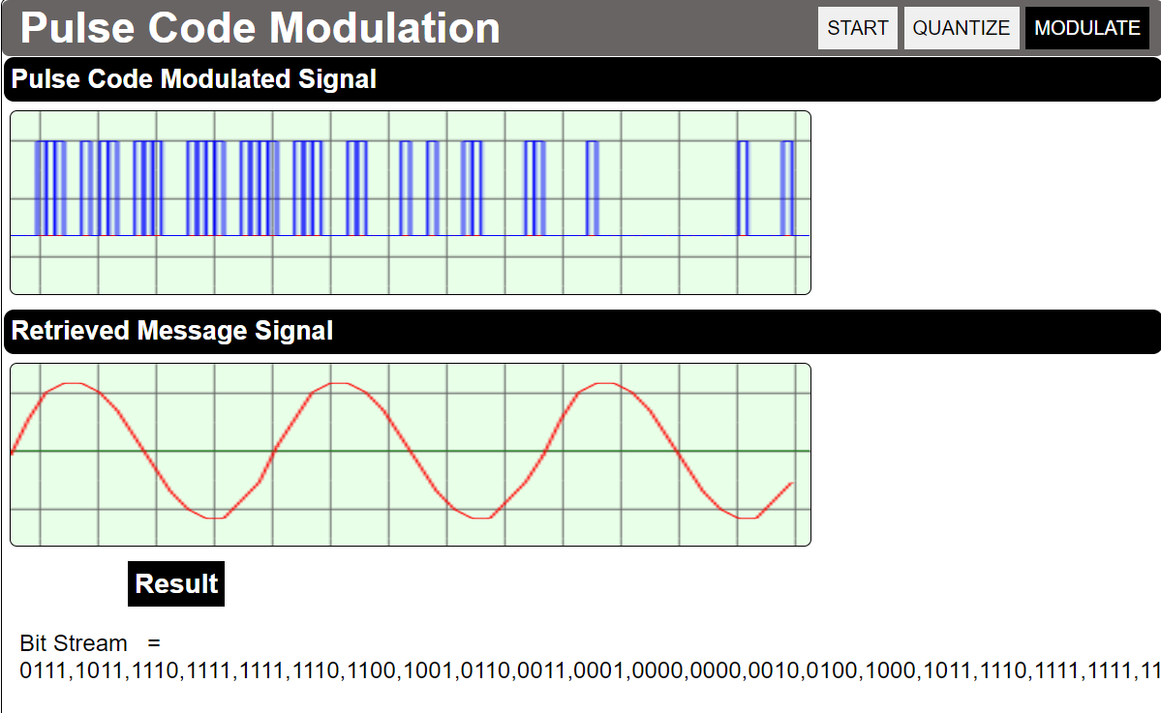

Fig. 15 Modulation screen of PCM simulator

**CONCLUSION**

The ensuing waveform is unmistakable.

The result achieved is consistent with the theory. The basic digital modulation waveforms techniques. As a result, we are successful achieving our goal in this paper.

AM: The amplitude of the carrier signal has been changed with respect to the amplitude of the message signal. The modulated signal has been demodulated using a method similar to envelop detection.

ASK: The carrier signal's strength is changed to indicate binary 1 or 0. While amplitude changes, both frequency and phase remain constant; in most cases, one of the amplitudes is zero.

FSK: The carrier signal's frequency is changed to represent binary 1 or 0. During each bit interval, the peak amplitude and phase stay unchanged. The FSK receiver is less prone to mistake than the ASK receiver, which seeks for particular frequency changes over many intervals. Voltage (noise) spikes can so be overlooked. FSK is utilized in voice lines, high-frequency radio transmission, and other applications.

FM: As can be seen in the FM modulation findings, the spectrum has a variety of upper and lower side bands, as well as the same equation as AM modulation. Sidebands are created when any carrier is modulated, and their bandwidth and amplitude are simple to calculate. Both the magnitude of deviation and the frequency modulation affect the sidebands of frequency modulation. As a result, the modulation spectrum included the carrier plus an infinite number of sidebands, as determined by the FM spectrum of the FM front panel in the findings.

PCM: By delving deeper into sampling and quantization, we can have a better understanding of Pulse Code Modulation. By sampling a signal at a rate lower than that required by the sampling theorem, you confirmed the introduction of aliasing. By restricting the number of bits used to represent a signal, you also verified the effect of lowering the quantization levels. Sampling and quantization are key principles in a wide range of engineering disciplines.

**REFERENCE PAPERS**

1. Shyam Diwakar, Krishnashree Achuthan and Prema Nedungadi. “Biotechnology virtual labs- Integrating wet-lab techniques and theoretical learning for enhanced learning at universities.”
2. 2. Jai P. Agrawal and Yakov E Cherner. “A Classroom/Distance Learning Engineering Course on Wireless Networking with Virtual Lab”.
3. Lavanya Rajendran, Ramachandran Veilumuthu and Divya. J. “study on the effectiveness of virtual lab in E-learning”
4. S. Diwakar, D. Kumar, R. Radhamani, H. Sasidharakurup, N. Nizar, K. Achuthan, P. Nedungadi, R. Raman, and B. Nair paper on Complementing Education via Virtual Labs: Implementation and Deployment of Remote Laboratories and Usage Analysis in South Indian Villages